Deploying MySql database using AWS RDS and make a Replica
28/7/2k26
Search Aurora and RDS ->Databases -> Create Database
- MySql ( all the sql feature )
- Aurora My( additional features along with Mysql)
- You can click “i” to know more about the options
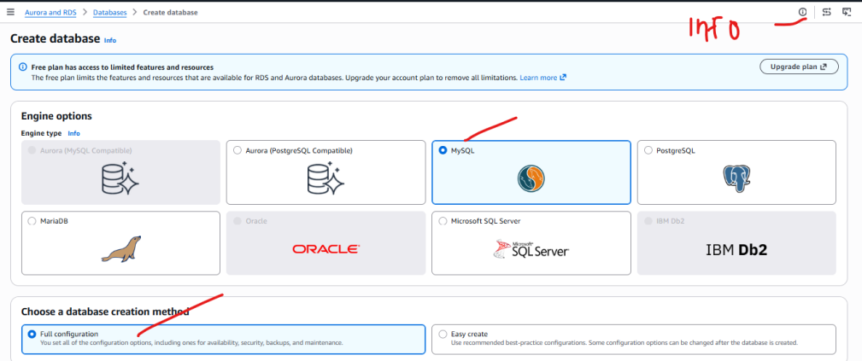
Single-AZ DB instance deployment
- it supports 1 instance and no data redundancy
- Both Read and write managed by same instance . so traffic load will be redirect to same server
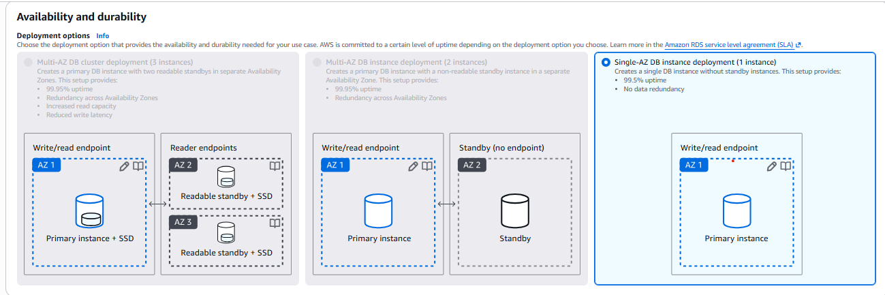
Select MySql version and give name (DB instance identifier) .
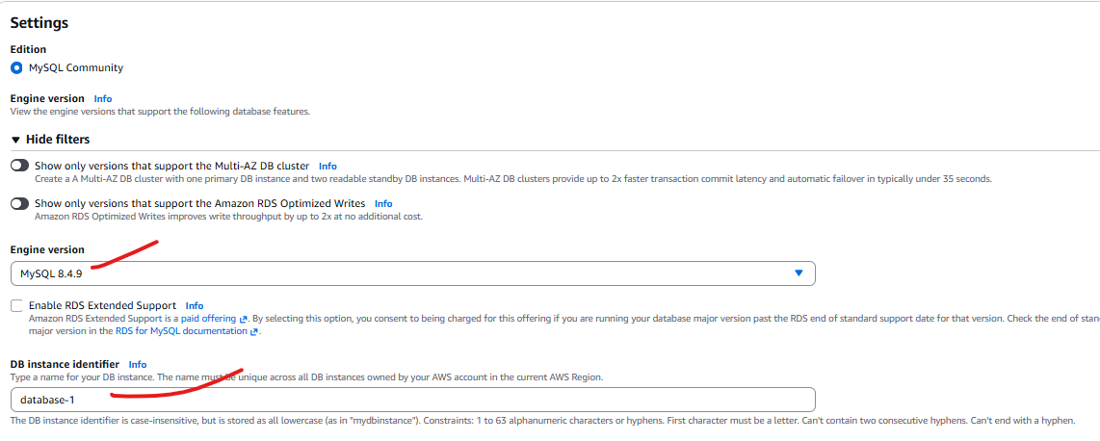

Just like there is a master user in MySql here also we need to give master user name(admin)
Self managed –we will manage the
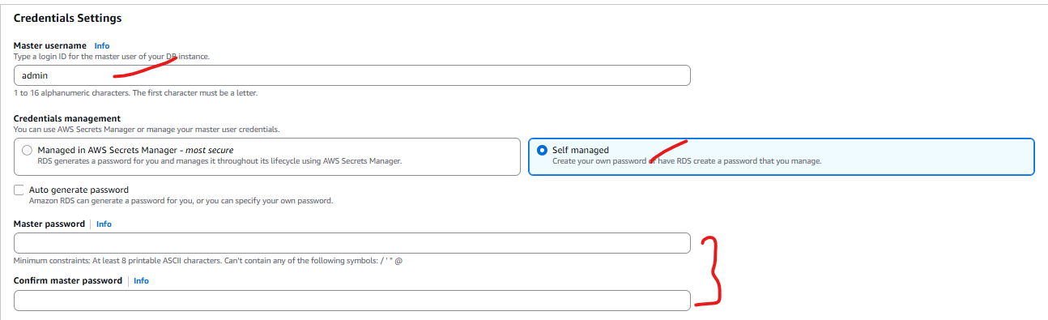

Keep the credentials password
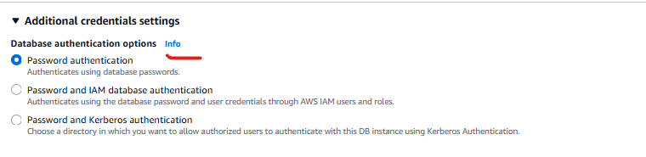
Instance type – the server where our MySql database will be hosted , the instance managed by aws.
Storage type- type of storage will use
Allocated storage – the space we want to allocate (measured in GB , min-20GB , Max -64 TB).
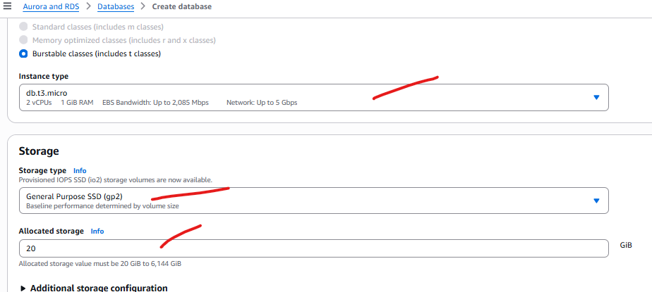

We don’t want to connect the database instance.
Keep default vpc
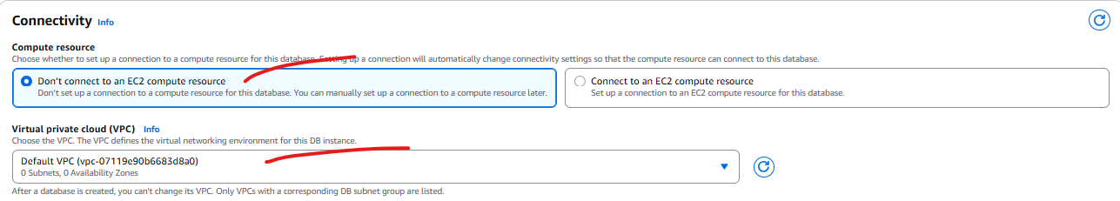
DB subnet group – we can provide subnets where we can deploy our DB (here selecting default )
Public – access type of DB
VPC security Group – just like SGs (here default value)
Availability zone – no preference
Then create Database
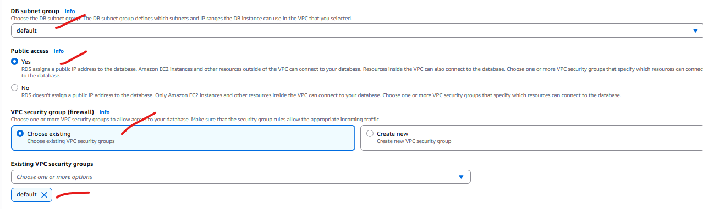
RDS database-1 instance deployed , its managed by RDS AWS.
Note * -If you want its full control (OS level) then install MySql in on an instance
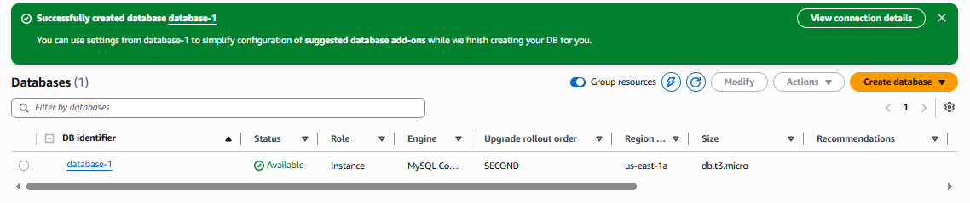

Now configure endpoint for Mysql connect .
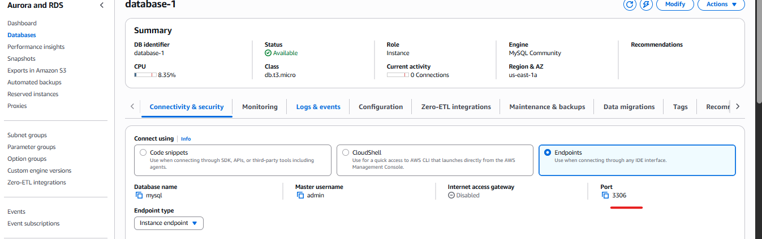
Select security group and allow access for MySql (port 3306).
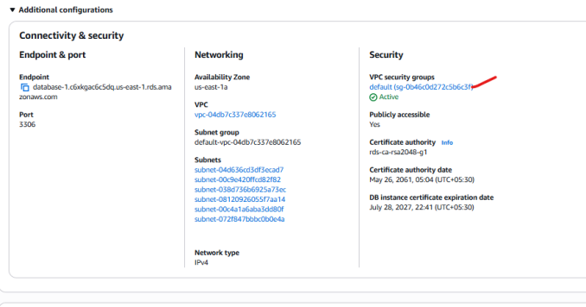

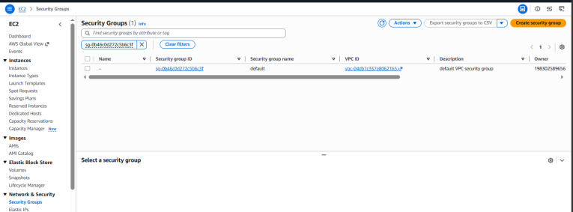

Give inbound rule MSSQL/Aurora (3306) – anywhere.
You can also give all traffic for checking purpose.
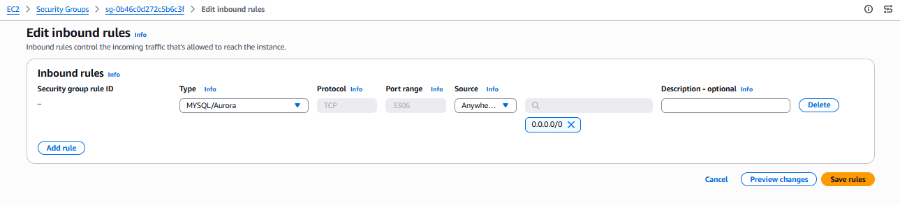
We use Putty ,RDP to connect EC2 instance , like that we will use Mysql Workbench to connect with database-1.
- Download My Sql workbench .( MySQL :: MySQL Workbench)
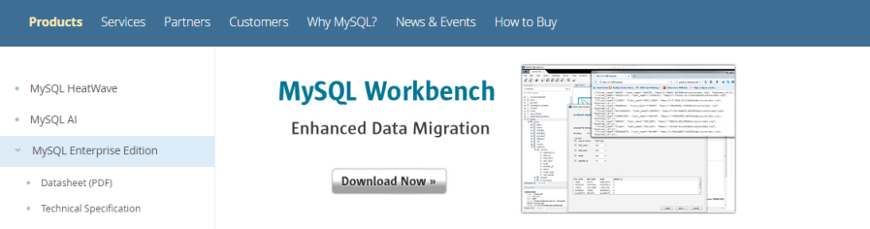
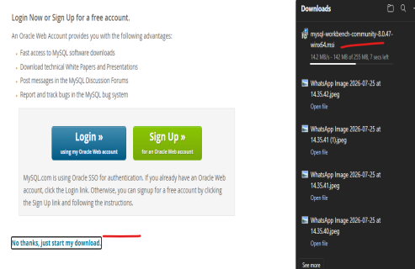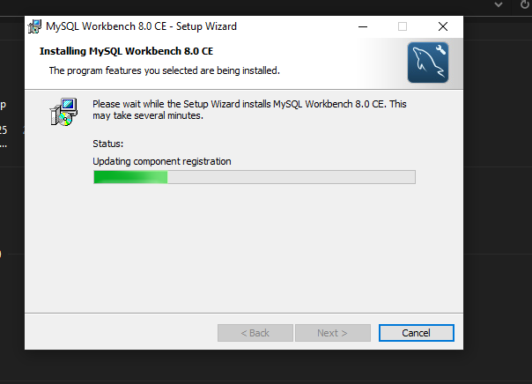

Create a new connection

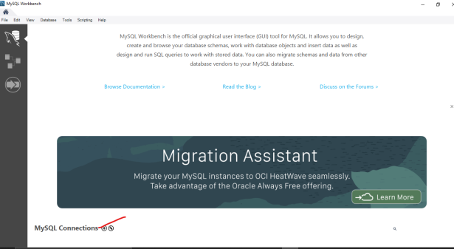

Connection – give any database name
Hostname – DB instance ip or endpoint (here endpoint - database-1.c6xkgac6c5dq.us-east-1.rds.amazonaws.com
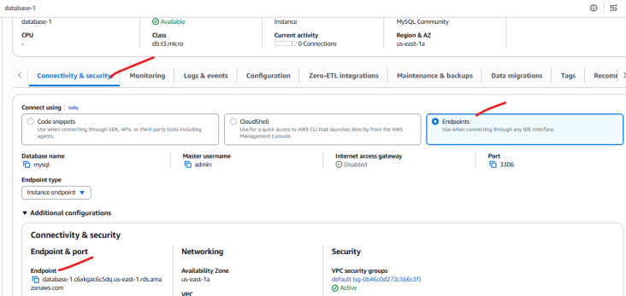
Port – MySql port number (3306)
Username- give the Master username that you had created at DB creation time (admin).
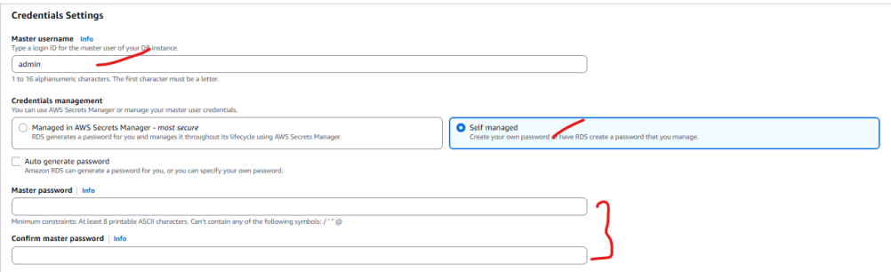

Password – give the password for Master username (admin) and click test connection.

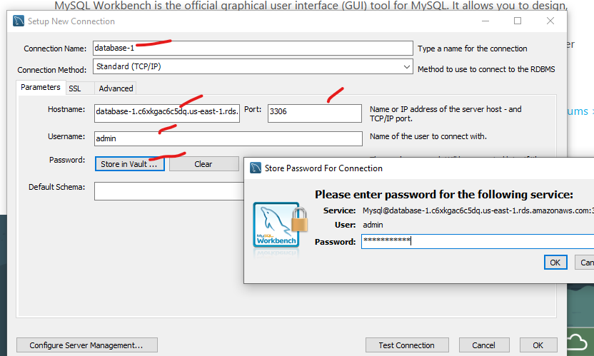

You will get successful connection . then click ok.
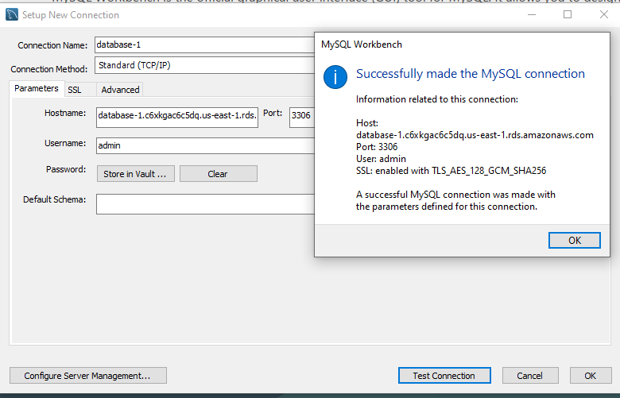

You will find the database-1 . click the database .
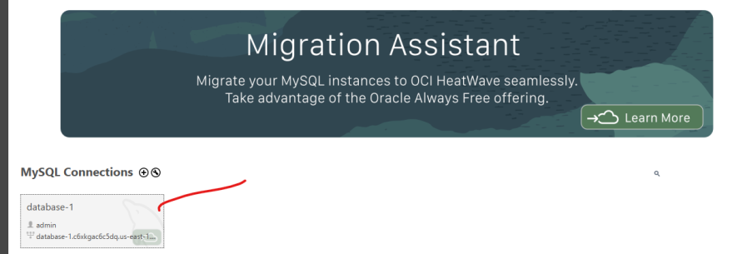
Now run a simple query to create a database named test.
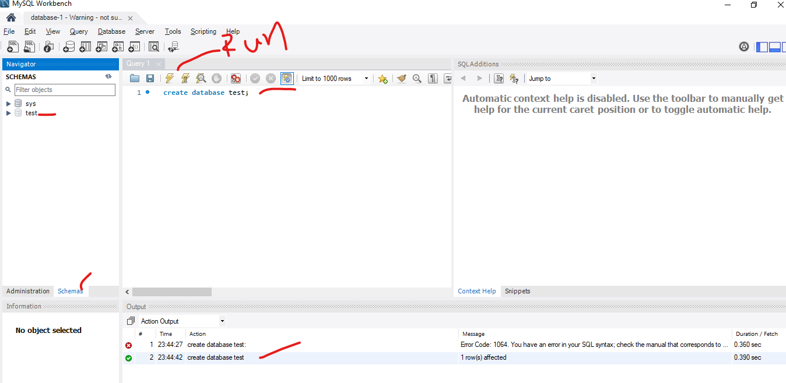

Run some Query
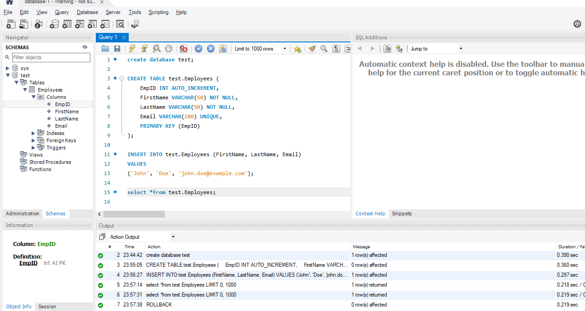

Now create a replica
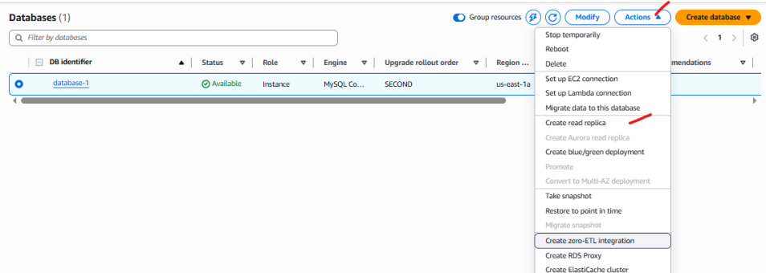

Give name of the replica . almost all option will be same , until we want some change.
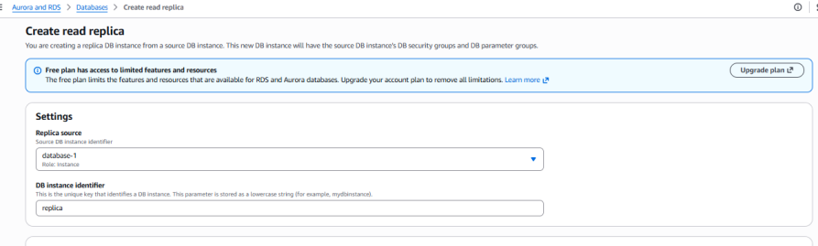
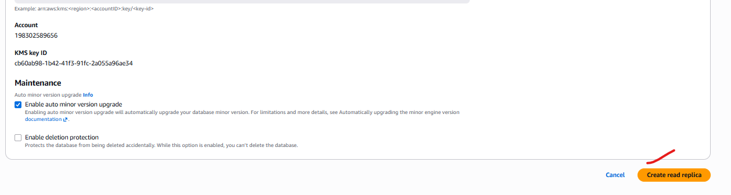

While creating replica , the primary database-1 also modifying , it means it syncing the data and configuration file in the background bye AWS RDS.

Note* - if we use select another region for replica , then it will not show in the primary RDS , we can find the replica in that location only .(select mentioned region > Aurora and RDS)
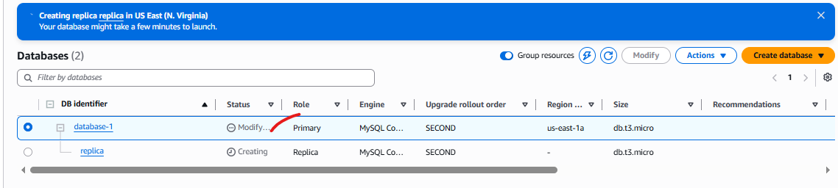

Once the replica available you can connect the replica in MySql workbench to check if the replicated data from primary DB is there or not . (user the same process which we followed for primary db)
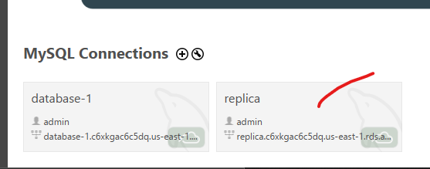

You can observe the database (test) already there in the replica .
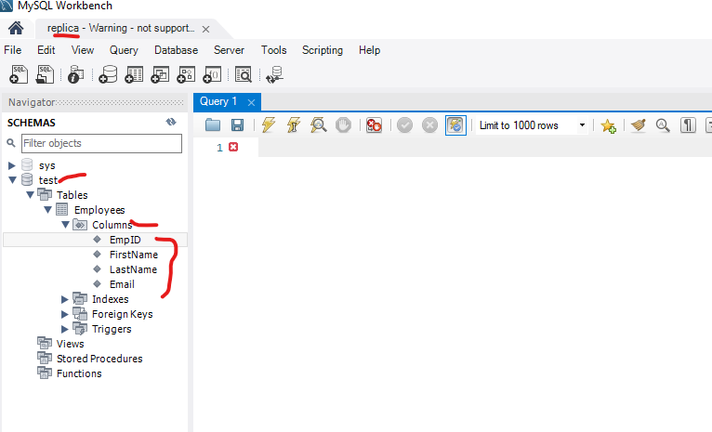

You can also check data sync ,change some data in primary DB and check if it reflecting in the replica.

Before

Primary DB(database-1) secondary DB(replica)
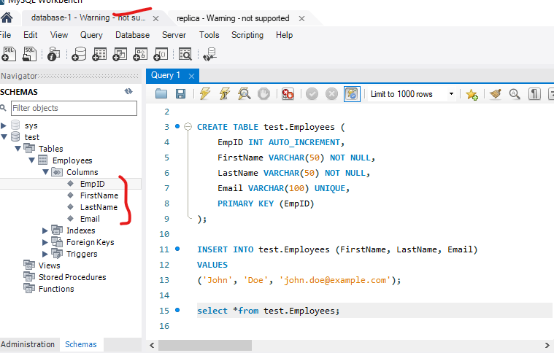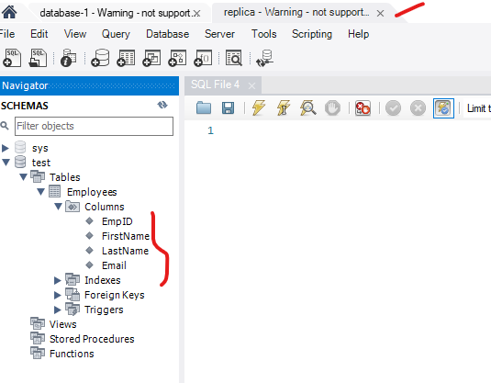

After –
Drop EmpID column in Primary DB(database-1) and see the secondary DB(replica)

Primary DB(database-1) secondary DB(replica)
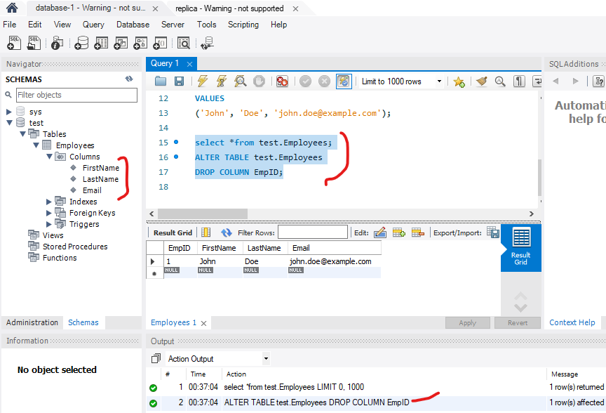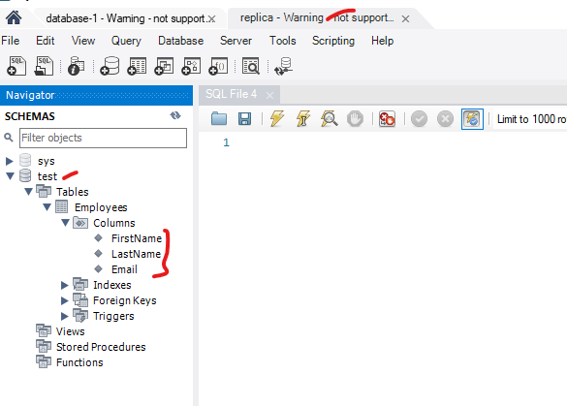

Now make change in secondary DB(replica) and see if its replicating in Primary DB(database-1)

secondary DB(replica)
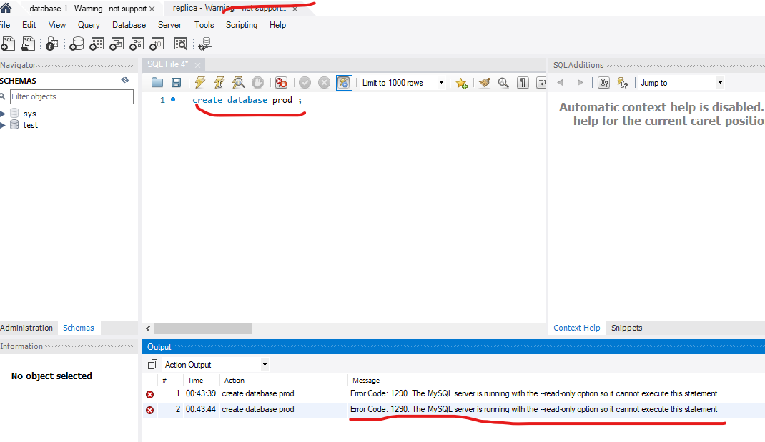

Since Replica has read-only permission , so we can not create /write/upload any data in replica database.

Task -completed

